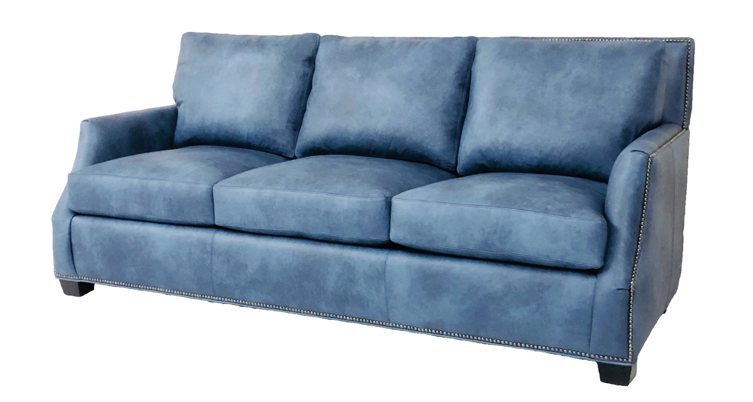
Style # 232 – Category 2
*All dimensions are approximate. AH: 25” AW:5” SH: 19” SD: 21” Overall Height: 36”

